“Linux Process Creation, Execution and Termination System”
A Project Report Submitted in the partial fulfillment of the requirements for the award of the degree of

BACHELOR OF TECHNOLOGY
In

DEPARTMENT OF COMPUTER SCIENCE ENGINNERING

By

J.SAHASRA 2520090067

D.KAVERI 2520090068

G.NAVYA SRI 2520090077

Under the Esteemed Guidance of

Raghupathi M
Assistant Professor
Department of Computer Science and Engineering




K L (Deemed to be) University DEPARTMENT OF COMPUTER SCIENCE ENGINEERING
&

DEPARTMENT OF COMPUTER SCIENCE AND INFORMATION TECHNOLY

Declaration

The Project Report entitled “Linux Process Creation, Execution and Termination System” is a record of Bonafide work of J.SAHASRA - 2520090067, D.KAVERI - 2520090068, G.NAVYA SRI - 2520090077,submitted inpartial fulfillment for the award of B. Tech in Computer Science and Engineering (or) Computer Science and Information Technology to the K L University. The results embodied in this report have not been copied from any other departments/University/Institute.

J.SAHASRA-2520090067

D.KAVERI-2520090068

G.NAVYA SRI-2520090077

K L (Deemed to be) University

DEPARTMENT OF COMPUTER SCIENCE ENGINEERING

CERTIFICATE

This is certify that the mini project based report entitled “Linux Process Creation, Execution and Termination System” is a bonafide work done and submitted by J.SAHASRA - 2520090067, D.KAVERI - 2520090068, G.NAVYA SRI - 2520090077, in partial fulfillment of the requirements for the award of the degree of BACHELOR OF TECHNOLOGY in Department of Computer Science Engineering, K L (Deemed to be University), during the academic year 2024-2025.

Signature of the Guide

Signature of the Course Coordinator Signature of the HOD

ACKNOWLEDGEMENT
The success in this project would not have been possible but for the timely help and guidance rendered by many people. Our wish to express my sincere thanks to all those who has assisted us in one way or the other for the completion of my project.

Our greatest appreciation to my Course Coordinator Dr. K. Anusha, and my guide Raghupathi M , Department of Computer Science which cannot be expressed in words for his/her tremendous support, encouragement and guidance for this project.

We express our gratitude to Dr. Khaja Shareef (CSIT), Head of the Department for Computer Science Engineering for providing us with adequate facilities, ways and means by which we are able to complete this project-based Lab.

We thank all the members of teaching and non-teaching staff members, and also who have assisted me directly or indirectly for successful completion of this project. Finally, I sincerely thank my parents, friends and classmates for their kind help and cooperation during my work.

J.SAHASRA-2520090067

D.KAVERI-2520090068

G.NAVYA SRI-2520090077

Abstract

A process is the basic unit of execution in an operating system, and understanding how processes are created, executed and terminated is essential in Operating Systems and Systems Programming. This project demonstrates the complete life cycle of a Linux process using C programs. It shows how a parent process creates a child using fork(), how the child runs a different program using the exec() family, how a process terminates normally with exit() or abnormally by a signal, and how the parent collects the exit status using wait() and waitpid().

The solution is implemented in a Linux/Ubuntu environment using C and the GCC compiler. Four programs are developed: process creation, process execution, process termination and zombie process demonstration. Each program prints the process identifiers (PID and PPID), the command being executed and the exit status or signal number so that the behaviour of the operating system can be observed directly.

The implementation is tested with different test cases, including normal creation, execution of another program, a missing or wrong command, normal termination with an exit status, termination by SIGKILL and a zombie process shown with the ps command. The project includes source code, a Makefile, build instructions, test results and terminal screenshots.

The expected outcome is a clear practical understanding of process creation, program execution, process termination, parent-child synchronization and Linux/POSIX system programming mechanisms.

Index

S. No. | Chapter | Topics / Subtopics | Page No.
 | Acknowledgement |  | i
 | Abstract |  | ii
1 | Introduction |  | 1–5
 |  | 1.1 Background of the Project
 |  | 1.2 Problem Statement
 |  | 1.3 Scope of the Project
 |  | 1.4 Objectives of the Project
 |  | 1.5 Importance of the Application
 |  | 1.6 Target Users / Audience
2 | OS Concepts and Background Study |  | 6–12
 |  | 2.1 Operating System Concepts Related to the Project
 |  | 2.2 Existing Methods / Algorithms
 |  | 2.3 Proposed Approach
 |  | 2.4 Advantages of the Proposed Approach
3 | System Requirements |  | 13–17
 |  | 3.1 Hardware Requirements
 |  | 3.2 Software Requirements
 |  | 3.3 Operating System Environment – Ubuntu / WSL
 |  | 3.4 Development Tools and Compilers
4 | Technology and Tools Used |  | 18–22
 |  | 4.1 C / C++ Programming
 |  | 4.2 GCC Compiler
 |  | 4.3 Linux System Calls
 |  | 4.4 Signals and Status Macros
 |  | 4.5 Linux Commands and Utilities
 |  | 4.6 Other Tools / Libraries Used
5 | System Architecture and Design |  | 23–29
 |  | 5.1 Overall System Architecture
 |  | 5.2System Workflow
 |  | 5.3 Flowchart / Data Flow
 |  | 5.4 Module Description
 |  | 5.5 Input and Output Design
6 | Implementation |  | 30–45
 |  | 6.1 Module-wise Implementation
 |  | 6.2 Algorithm / Pseudocode
 |  | 6.3 Core C Implementation
 |  | 6.4 Linux System Calls / APIs Used
 |  | 6.5 Process Creation and Execution Implementation
 |  | 6.6 Process Termination and Synchronization Implementation
 |  | 6.7 Zombie and Orphan Process Handling
 |  | 6.8 Makefile and Build Automation
7 | Execution and Demonstration |  | 62–67
 |  | 7.1 Compilation in Ubuntu
 |  | 7.2 Execution Commands
 |  | 7.3 Sample Inputs and Outputs
 |  | 7.4 Screenshots of Execution
 |  | 7.5 Demonstration of OS Concepts
8 | Conclusion |  | 79–83
 |  | 8.1 Summary of the Project
 |  | 8.2 Objectives Achieved
 |  | 8.3 Results Achieved
 |  | 8.4 Skills and Learning Outcomes
9 | References |  | 84–86
 |  | 9.1 Books
 |  | 9.2 Research Papers
 |  | 9.3 Linux / GNU Documentation
 |  | 9.4 Online Resources

CHAPTER -1 INTRODUCTION

1.1 Background of the Project

An operating system manages the resources of a computer and provides an environment in which programs can run. The most important unit of work in an operating system is the process. A process is a program in execution, and every command typed into a Linux terminal, every application started by the user and every background service runs as one or more processes.

Linux follows the UNIX process model. A new process is never created from nothing; it is always created by an existing process. The existing process is called the parent and the new process is called the child. The parent creates the child using the fork() system call. The child can then replace its own program with a different program using one of the exec() functions. When the child has finished its work it terminates using exit(), and the parent collects the result using wait() or waitpid().

This sequence of creation, execution and termination is called the life cycle of a process. It is used every time the shell starts a command such as ls or gcc, so understanding it is essential for Operating Systems and Linux system programming.

This project, "Linux Process Creation, Execution and Termination System", demonstrates the complete life cycle of a Linux process using small C programs. The programs show how a process is created with fork(), how a program is executed with execvp(), how a process terminates normally with exit() or abnormally by a signal, how the parent reads the exit status, and how zombie processes appear when a parent does not call wait().

1.2 Problem Statement

Process management is explained in textbooks mainly through diagrams and theory. Students often find it difficult to see what really happens inside the operating system when a process is created, when a program is loaded into it and when it terminates. Questions such as "who is the parent of this process?", "what does fork() return in the child?", "what happens to the old program after exec()?" and "why does a finished process still appear in the process list?" are hard to answer without running real code.

The problem addressed by this project is the lack of a simple, practical demonstration of the complete process life cycle on Linux. The project solves it by providing four small C programs that create processes, execute other programs, terminate processes in different ways and display the process identifiers and exit status at every step.

1.3 Scope of the Project

The scope of the project includes the design, implementation and testing of C programs on Ubuntu Linux that demonstrate the following:

Process creation using fork() and identification of parent and child using getpid() and getppid().

Program execution inside a child process using the exec() family (execvp()).

Normal process termination using exit() with a user-defined exit status.

Abnormal process termination caused by a signal (SIGKILL).

Parent-child synchronization using wait() and waitpid().

Reading the termination status using WIFEXITED(), WEXITSTATUS(), WIFSIGNALED() and WTERMSIG().

Detection of a zombie process using the ps command.

Error handling when fork() or exec() fails.

Compilation and execution using GCC and Make on Ubuntu/WSL.

The project is intended for educational and laboratory demonstration purposes. Thread management, inter-process communication and memory management are outside the scope of this project.

1.4 Objectives of the Project

The main objectives of the project are:

To understand the concept of a process and the parent-child relationship in Linux.

To demonstrate process creation using the fork() system call.

To demonstrate program execution in a child process using execvp().

To demonstrate normal and abnormal process termination using exit() and signals.

To demonstrate synchronization between parent and child using wait() and waitpid().

To read and interpret the exit status of a terminated child process.

To demonstrate zombie processes and how they are removed.

To handle errors in process creation and execution correctly.

To document the implementation, test cases and results with screenshots.

1.5 Importance of the Application

Process creation, execution and termination are the basis of everything that happens in a Linux system. The shell, system services, web servers and compilers all use fork(), exec() and wait(). A student who understands these three operations understands how a UNIX-like operating system starts and manages programs.

The programs developed in this project are small enough to be read and explained in a laboratory session, yet they use the same system calls as a real shell. The printed process identifiers and exit statuses make the abstract ideas of parent, child, process image and exit status visible and easy to verify.

1.6 Target Users / Audience

The main target users are:

Operating System students.

Computer Science and Information Technology students.

Students learning Linux and C system programming.

Faculty members demonstrating process management.

Beginners learning system calls such as fork(), exec() and wait().

Students preparing for OS laboratory examinations and viva.

CHAPTER -2 OS CONCEPTS AND BACKGROUND STUDY

2.1 Operating System Concepts Related to the Project

Process

A process is a program in execution. A program is a passive file stored on disk, while a process is an active entity that has its own address space (code, data, heap and stack), registers, open files and a unique process identifier (PID). Several processes can run the same program at the same time, and each has a different PID.

Process Control Block (PCB)

The operating system keeps all information about a process in a data structure called the Process Control Block. In Linux this is the task_struct structure. The PCB stores the PID, the parent PID (PPID), the process state, the CPU registers and program counter, memory-management information, the list of open files, scheduling information and, after termination, the exit status.

Process States

During its life a process moves between several states: New (being created), Ready (waiting for the CPU), Running (executing on the CPU), Waiting (blocked for an event such as I/O or the termination of a child) and Terminated (finished). Linux also has the Zombie state, which is described below.

Process Creation - fork()

fork() creates a new process by duplicating the calling process. After fork() there are two processes running the same code. The call returns twice: it returns the PID of the child to the parent, it returns 0 to the child, and it returns -1 if the child could not be created. This return value is how a program decides whether it is running as the parent or as the child.

Process Execution - exec()

The exec() family of functions (execl, execlp, execle, execv, execvp and execve) replaces the program of the calling process with a new program. The PID does not change, but the code, data, heap and stack are replaced. If exec() succeeds it never returns; it returns -1 only when it fails, for example when the command does not exist. The combination of fork() followed by exec() is how a shell runs every command.

Process Termination - exit() and Signals

A process terminates normally when it returns from main() or calls exit(status). exit() flushes the standard I/O buffers, runs registered exit handlers and then asks the kernel to destroy the process. The status value (0 to 255) is passed to the parent; by convention 0 means success and a non-zero value means an error. A process terminates abnormally when it receives a signal such as SIGKILL (9) or SIGTERM (15) that is not handled.

Synchronization - wait() and waitpid()

wait() suspends the parent until one of its children terminates and then returns the PID of that child and its termination status. waitpid() allows the parent to wait for one specific child. The macros WIFEXITED(), WEXITSTATUS(), WIFSIGNALED() and WTERMSIG() are used to interpret the status.

Zombie and Orphan Processes

When a child terminates, the kernel releases its memory but keeps a small entry in the process table so that the parent can still read its exit status. A terminated child whose parent has not yet called wait() is a zombie process (state Z). It disappears as soon as the parent calls wait(). If the parent terminates before the child, the child becomes an orphan and is adopted by the init process (PID 1, systemd on Ubuntu), which calls wait() for it.

2.2 Existing Methods / Algorithms

Process management is usually taught with theoretical diagrams of the process state model and with isolated examples in textbooks. In the laboratory, a student normally types commands such as ps, top and kill in the terminal and observes the result, but this does not show how a program itself creates and ends processes.

The shell is the most common real-life example of fork-exec-wait. When the user types ls, the shell calls fork(), the child calls exec() to run ls, and the shell calls wait() until ls finishes. The shell code is large and complex, so it is not suitable for beginners to study directly.

Because of this, a small and focused implementation is needed in which every step is visible and every identifier is printed.

2.3 Proposed Approach

The proposed system consists of four small C programs. Each program demonstrates one stage of the process life cycle and prints the PID, PPID and exit status so that the behaviour can be verified. The programs are compiled with GCC, built with a Makefile and run from the Ubuntu terminal.

The four modules are:

Module 1 - process_create : process creation using fork().

Module 2 - process_exec : program execution using fork() and execvp().

Module 3 - process_terminate : normal and abnormal termination and exit status using exit(), a signal and wait().

Module 4 - process_zombie : zombie process demonstration and removal using wait().

2.4 Advantages of the Proposed Approach

Uses the real Linux system calls instead of a simulation.

Each module is small and easy to read and explain.

Shows parent and child identifiers clearly through PID and PPID output.

Demonstrates both normal and abnormal termination.

Shows the exit status passed from child to parent.

Makes zombie processes visible with the ps command.

Handles errors such as exec failure and missing arguments.

Requires no special hardware or libraries.

Easy to compile and run in Ubuntu or WSL.

Suitable for beginners and for laboratory demonstration.

CHAPTER -3 SYSTEM REQUIREMENTS

3.1 Hardware Requirements

The project does not require special hardware. It can run on an ordinary student laptop or desktop computer.

Minimum Requirements
Component | Requirement
Processor | Intel/AMD dual-core or above
RAM | 2 GB minimum (4 GB recommended)
Storage | 1 GB available space
Keyboard and Mouse | Standard keyboard and mouse
Display | Standard monitor
Internet | Required for initial software installation

3.2 Software Requirements

The following software is required:

Ubuntu Linux (20.04 or later) or Ubuntu through WSL.

GCC compiler (build-essential package).

Make utility.

C programming language and the POSIX/GNU C library.

Linux terminal (bash shell).

procps tools (ps command) for the zombie demonstration.

Visual Studio Code or any text editor (optional).

Git and GitHub for version control (optional).

3.3 Operating System Environment - Ubuntu / WSL

The project is designed to run in a Linux environment because it uses POSIX system calls such as fork(), execvp() and waitpid(), which are not available in the Windows native environment. Ubuntu can be installed directly on a computer, in a virtual machine, or used through the Windows Subsystem for Linux (WSL).

WSL allows Linux commands and development tools to be used inside Windows. The required tools can be installed with:
sudo apt update
sudo apt install build-essential procps

Files stored on the Windows D: drive can be accessed from WSL under /mnt/d. For example, a project stored at D:\ProcessProject is opened with:
cd /mnt/d/ProcessProject

3.4 Development Tools and Compilers

GCC

GCC is used to compile the C programs. For example:
gcc process_create.c -o process_create

Make

The make utility reads the Makefile and compiles all four programs with a single command, make.

Visual Studio Code

VS Code can be used for editing the C source files and has an integrated terminal.

Linux Terminal

The terminal is used for compiling, running and testing the programs and for running the ps command.

CHAPTER -4 TECHNOLOGY AND TOOLS USED

4.1 C / C++ Programming

C is the programming language used for the project. Linux itself is written in C and its system-call interface is defined for C programs, so fork(), execvp(), wait() and exit() can be used directly without any wrapper.

C is chosen instead of C++ because the project demonstrates operating system calls and needs no object-oriented features.

4.2 GCC Compiler

GCC stands for GNU Compiler Collection. It compiles the C source files into executable programs. The -Wall option enables all common warnings and the -o option gives the name of the output file.
gcc -Wall process_create.c -o process_create
./process_create

4.3 Linux System Calls

The project uses the following Linux/POSIX system calls and library functions:
Function | Header | Purpose
fork() | <unistd.h> | Creates a child process by duplicating the parent
execvp() | <unistd.h> | Replaces the process image with a new program, searching PATH
wait() | <sys/wait.h> | Blocks the parent until any child terminates
waitpid() | <sys/wait.h> | Waits for a specific child and returns its status
exit() | <stdlib.h> | Terminates the calling process with a status value
getpid() | <unistd.h> | Returns the PID of the calling process
getppid() | <unistd.h> | Returns the PID of the parent process
raise() | <signal.h> | Sends a signal to the calling process itself
perror() | <stdio.h> | Prints a system error message
system() | <stdlib.h> | Runs a shell command (used to run ps)

4.4 Signals and Status Macros

A signal is a software notification sent to a process. SIGKILL (signal 9) terminates a process immediately and cannot be caught or ignored. SIGTERM (signal 15) is the normal request to terminate and can be handled. SIGCHLD is sent to the parent when a child terminates.

After wait() returns, the status value is interpreted using macros:
Macro | Meaning
WIFEXITED(status) | True if the child terminated normally (exit or return)
WEXITSTATUS(status) | The exit code (0 to 255) passed by the child
WIFSIGNALED(status) | True if the child was terminated by a signal
WTERMSIG(status) | The number of the signal that terminated the child

4.5 Linux Commands and Utilities

Some important Linux commands used during development and testing are:
Command | Purpose
cd, ls, pwd | Move to the project folder, list files and show the current directory
gcc, make | Compile the programs
./program | Run a compiled program
ps -o pid,ppid,stat,comm -p PID | Show the PID, parent PID and state of a process (Z = zombie)
echo $? | Display the exit status of the last command
kill -9 PID | Send SIGKILL to a process

4.6 Other Tools / Libraries Used

Make / Makefile

Automates compilation of all programs and provides a clean target to remove the executables.

Git / GitHub

Used for version control and for sharing the source code between the team members.

Terminal screenshots

The execution results are captured as terminal screenshots and included in Chapter 7 as evidence.

CHAPTER -5 SYSTEM ARCHITECTURE AND DESIGN

5.1 Overall System Architecture

The system has three layers. The user types a command in the bash shell. The shell starts one of the four C programs in user space. The programs request services from the Linux kernel through the system-call interface, and the kernel creates, runs and destroys processes while keeping their details in the process table.
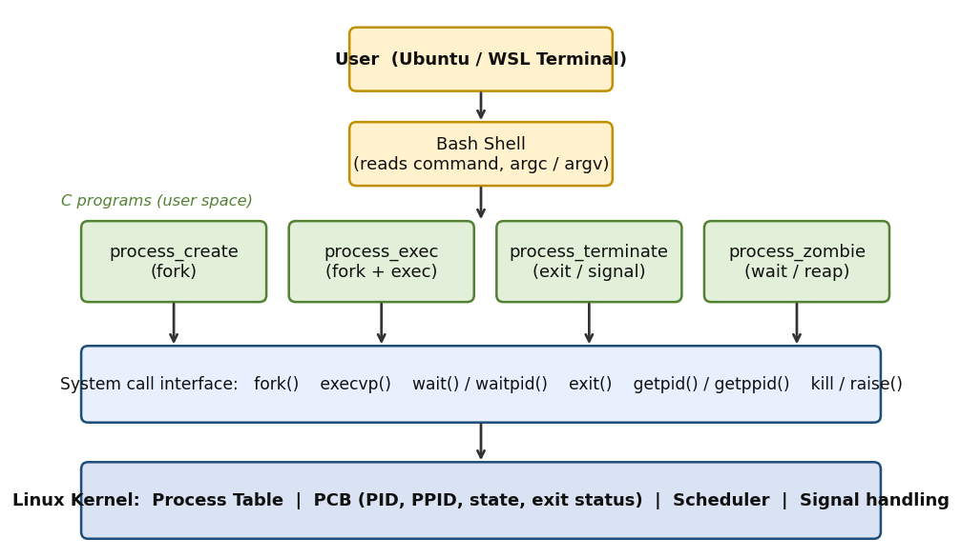
Figure 5.1: Overall architecture of the system

5.2 System Workflow

The user opens the Ubuntu terminal and compiles the programs with make.

The user runs a program from the shell, for example ./process_exec echo Hello.

The program checks its command-line arguments and prints a banner.

The parent process calls fork() to create a child process.

The child process prints its PID and PPID and, if required, calls execvp() to run another program.

The child terminates with exit(status) or is killed by a signal.

The parent calls wait() or waitpid() and receives the termination status.

The parent displays the exit status or signal number and finishes.

5.3 Flowchart / Data Flow

The flowchart below shows the life cycle of a process: creation by fork(), optional execution by execvp(), termination by exit() or a signal, and collection of the status by the parent.
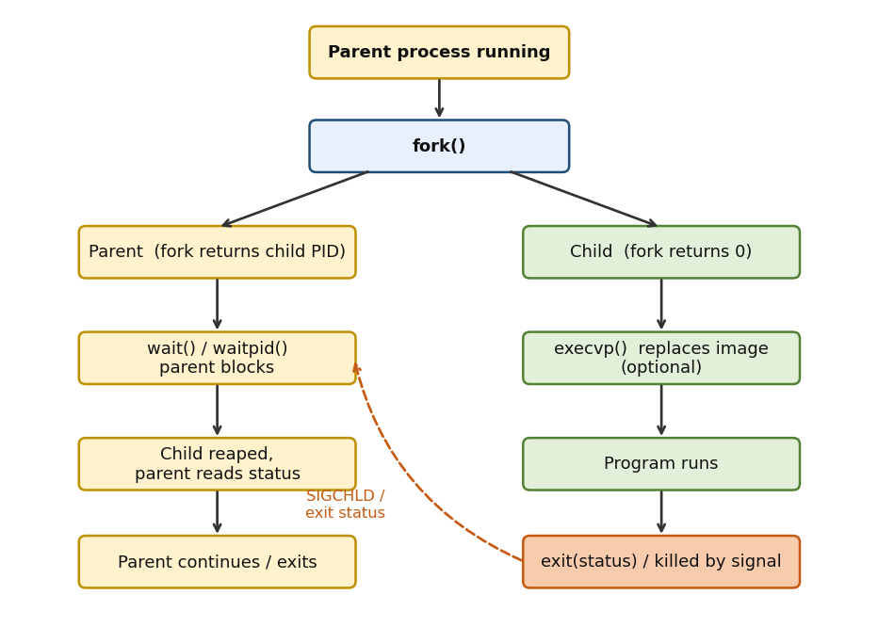
Figure 5.2: Life cycle of a process - fork, exec, exit and wait

5.4 Module Description
Module | Description
process_create | Creates a child with fork(); both processes print their PID and PPID; the parent waits for the child.
process_exec | Creates a child with fork(); the child runs a command given on the command line using execvp(); the parent reports the exit status.
process_terminate | Creates a child that terminates with a chosen exit code or is killed by SIGKILL; the parent identifies the type of termination.
process_zombie | Creates a child that exits immediately; the parent shows the zombie state with ps and then removes it with wait().

5.5 Input and Output Design

Input

The programs accept the following input from the command line:

process_create : no input.

process_exec : a command name and its arguments, for example echo Hello Linux.

process_terminate : a numeric exit code (default 0) or the letter s to terminate the child with a signal.

process_zombie : no input.

Output

The programs display:

Parent and child process identifiers (PID and PPID).

The command that is being executed.

The output of the executed program.

The exit status or signal number of the child.

The process state obtained from ps (zombie and removed).

Usage and error messages for invalid input or failed exec.

CHAPTER -6 IMPLEMENTATION

6.1 Module-wise Implementation

The project is implemented as four small, independent C programs. Each program demonstrates one stage of the process life cycle. Keeping every concept in its own program makes the code easy to read, compile, test and explain in a review.

Module 1: Process Creation Program (process_create.c)

This program prints its own PID and then calls fork(). The child prints its PID and the PID of its parent and exits with status 0. The parent prints its PID and the PID of the child and calls wait() so that it resumes only after the child has terminated. This module was designed and implemented by J. Sahasra.

Module 2: Process Execution Program (process_exec.c)

This program takes a command and its arguments from the command line. The child created by fork() replaces itself with that command using execvp(). The parent waits with waitpid() and reports the exit status of the command. If the command does not exist, the child prints an error and exits with status 127. This module was designed and implemented by D. Kaveri.

Module 3: Process Termination Program (process_terminate.c)

This program shows how a child process can end. With a number as argument the child calls exit() with that number. With the argument s the child sends SIGKILL to itself using raise(). The parent uses wait() and the macros WIFEXITED() and WIFSIGNALED() to find out how the child ended. This module was designed and implemented by G. Navya Sri.

Module 4: Zombie Process Program (process_zombie.c)

This program creates a child that exits immediately while the parent sleeps for one second without calling wait(). The parent then runs the ps command to show that the child is in the zombie state (Z), calls wait() and runs ps again to show that the zombie has been removed. This module was implemented and tested jointly by all three team members.

Summary of Modules
Module | OS Concept Demonstrated | Key Functions / APIs
process_create | Process creation, parent-child relationship | fork(), getpid(), getppid(), wait()
process_exec | Program execution, exec failure handling | fork(), execvp(), waitpid(), WEXITSTATUS()
process_terminate | Normal and abnormal termination, exit status | exit(), raise(), wait(), WIFEXITED(), WIFSIGNALED()
process_zombie | Zombie process and its removal | fork(), exit(), wait(), system()

6.2 Algorithm / Pseudocode

Algorithm 1: Process Creation (process_create)
1. START
2. Print the heading and the parent PID using getpid()
3. pid = fork()
4. IF pid < 0 THEN
Print error using perror() and RETURN 1
5. IF pid == 0 THEN (child process)
Print child PID and parent PID (getppid())
EXIT(0)
ELSE (parent process)
Print parent PID and child PID (pid)
wait(NULL)
Print "Child has terminated. Parent resumes."
6. RETURN 0
7. STOP

Algorithm 2: Process Execution (process_exec)
1. START
2. IF argc < 2 THEN
Print usage message and RETURN 1
3. Print parent PID and the command argv[1]
4. pid = fork()
5. IF pid < 0 THEN perror() and RETURN 1
6. IF pid == 0 THEN (child process)
execvp(argv[1], &argv[1])
Print "exec failed" using perror()
EXIT(127) (reached only if exec fails)
ELSE (parent process)
waitpid(pid, &status, 0)
IF WIFEXITED(status) THEN Print WEXITSTATUS(status)
7. RETURN 0
8. STOP

Algorithm 3: Process Termination (process_terminate)
1. START
2. Read the argument: "s" -> use_signal = 1, number -> code = number
3. pid = fork()
4. IF pid == 0 THEN (child process)
IF use_signal THEN raise(SIGKILL)
ELSE EXIT(code)
ELSE (parent process)
wait(&status)
IF WIFEXITED(status) THEN Print WEXITSTATUS(status)
ELSE IF WIFSIGNALED(status) THEN Print WTERMSIG(status)
5. RETURN 0
6. STOP

Algorithm 4: Zombie Process (process_zombie)
1. START
2. pid = fork()
3. IF pid == 0 THEN (child process)
EXIT(0) (child terminates at once)
4. Parent: sleep(1) (child is now a zombie)
5. Run ps -o pid,ppid,stat,comm -p pid -> state Z
6. wait(NULL) (zombie is removed)
7. Run ps again -> process no longer listed
8. RETURN 0
9. STOP

6.3 Core C Implementation

The complete source code of the four programs is given below.

Program: process_create.c
#include <stdio.h>
#include <stdlib.h>
#include <unistd.h>
#include <sys/wait.h>

int main(void)
{
printf("====================================\n");
printf(" PROCESS CREATION DEMO (fork)\n");
printf("====================================\n");
printf("Parent process PID : %d\n", getpid());
printf("Creating child process using fork()...\n");

fflush(stdout);
pid_t pid = fork();

if (pid < 0)
{
perror("fork failed");
return 1;
}

if (pid == 0)
{
printf("\n--- CHILD PROCESS ---\n");
printf("Child PID : %d\n", getpid());
printf("Parent PID : %d\n", getppid());
printf("Child is exiting with status 0\n");
exit(0);
}
else
{
printf("\n--- PARENT PROCESS ---\n");
printf("Parent PID : %d\n", getpid());
printf("Child PID : %d\n", pid);
wait(NULL);
printf("Child has terminated. Parent resumes.\n");
}
printf("====================================\n");
return 0;
}

Explanation of process_create.c

getpid() returns the PID of the calling process and getppid() returns the PID of its parent.

fflush(stdout) before fork() empties the output buffer. Without it, text waiting in the buffer would be copied into the child and printed twice when the output is redirected to a file or pipe.

fork() returns a negative value on failure, 0 in the child and the child PID in the parent. The if-else structure uses this to give each process different work.

exit(0) ends the child immediately so that it does not run the parent code that follows.

wait(NULL) blocks the parent until the child terminates, which prevents the child from becoming a zombie.

Program: process_exec.c
#include <stdio.h>
#include <stdlib.h>
#include <unistd.h>
#include <sys/wait.h>

int main(int argc, char *argv[])
{
printf("====================================\n");
printf(" PROCESS EXECUTION DEMO (fork+exec)\n");
printf("====================================\n");

if (argc < 2)
{
printf("Usage: %s <command> [arguments...]\n", argv[0]);
return 1;
}

printf("Parent PID : %d\n", getpid());
printf("Command to execute : %s\n\n", argv[1]);
fflush(stdout);

pid_t pid = fork();

if (pid < 0)
{
perror("fork failed");
return 1;
}

if (pid == 0)
{
printf("--- CHILD PROCESS (PID %d) ---\n", getpid());
printf("Replacing process image using execvp()...\n\n");
fflush(stdout);
execvp(argv[1], &argv[1]);
perror("exec failed");
exit(127);
}
else
{
int status;
waitpid(pid, &status, 0);
printf("\n--- PARENT PROCESS ---\n");
printf("Child PID %d finished.\n", pid);
if (WIFEXITED(status))
printf("Child exit status : %d\n", WEXITSTATUS(status));
}
printf("====================================\n");
return 0;
}

Explanation of process_exec.c

The program first checks argc < 2. If no command is supplied, it prints the usage and returns 1.

execvp(argv[1], &argv[1]) replaces the child with the requested command. argv[1] is the command name and &argv[1] is the argument list; the list ends with NULL, which main() already provides.

The "p" in execvp means the command is searched in the directories of the PATH variable, so ls can be written without /bin/.

exec never returns on success. The perror() and exit(127) statements run only if exec fails, for example when the command does not exist. 127 is the exit code the shell uses for "command not found".

waitpid(pid, &status, 0) waits for that particular child, and WIFEXITED()/WEXITSTATUS() read how it ended.

Program: process_terminate.c
#include <stdio.h>
#include <stdlib.h>
#include <unistd.h>
#include <signal.h>
#include <string.h>
#include <sys/wait.h>

int main(int argc, char *argv[])
{
int code = 0;
int use_signal = 0;

printf("====================================\n");
printf(" PROCESS TERMINATION DEMO\n");
printf("====================================\n");

if (argc >= 2 && argv[1][0] == 's')
use_signal = 1;
else if (argc >= 2)
code = atoi(argv[1]);

fflush(stdout);
pid_t pid = fork();

if (pid < 0)
{
perror("fork failed");
return 1;
}

if (pid == 0)
{
printf("Child PID : %d\n", getpid());
if (use_signal)
{
printf("Child is waiting to be killed by a signal...\n");
fflush(stdout);
raise(SIGKILL);
}
printf("Child terminates with exit(%d)\n", code);
fflush(stdout);
exit(code);
}
else
{
int status;
wait(&status);
printf("\n--- PARENT PROCESS ---\n");
printf("Parent collected child PID %d using wait()\n", pid);
if (WIFEXITED(status))
printf("Child exited normally, exit status = %d\n", WEXITSTATUS(status));
else if (WIFSIGNALED(status))
printf("Child killed by signal %d (%s)\n", WTERMSIG(status), strsignal(WTERMSIG(status)));
}
printf("====================================\n");
return 0;
}

Explanation of process_terminate.c

If the first argument starts with s, use_signal is set; otherwise atoi() converts the argument to the exit code.

In the child, raise(SIGKILL) sends signal 9 to the process itself. SIGKILL cannot be caught, so the child is killed immediately and the lines after raise() are never executed.

exit(code) terminates the child normally and passes code to the parent as the exit status.

In the parent, wait(&status) collects the child. WIFEXITED() is true for a normal exit and WEXITSTATUS() gives the code; WIFSIGNALED() is true when a signal killed the child and WTERMSIG() gives the signal number.

strsignal() converts the signal number into text, for example "Killed" for signal 9.

Program: process_zombie.c
#include <stdio.h>
#include <stdlib.h>
#include <unistd.h>
#include <sys/wait.h>

int main(void)
{
char cmd[100];

printf("====================================\n");
printf(" ZOMBIE PROCESS DEMO\n");
printf("====================================\n");
printf("Parent PID : %d\n", getpid());
fflush(stdout);

pid_t pid = fork();

if (pid < 0)
{
perror("fork failed");
return 1;
}

if (pid == 0)
{
printf("Child PID %d exits immediately.\n", getpid());
exit(0);
}

sleep(1);
snprintf(cmd, sizeof(cmd), "ps -o pid,ppid,stat,comm -p %d", pid);

printf("\nChild has exited but parent has not called wait().\n");
printf("State of child (Z = zombie):\n");
fflush(stdout);
system(cmd);

wait(NULL);

printf("\nParent called wait(). Zombie removed.\n");
printf("State of child now:\n");
fflush(stdout);
system(cmd);

printf("====================================\n");
return 0;
}

Explanation of process_zombie.c

The child calls exit(0) immediately, but the parent does not call wait() yet. The child has finished, but its process-table entry remains because the parent has not read its status; this is the zombie state.

sleep(1) gives the child time to terminate before the parent checks it.

snprintf() builds the command ps -o pid,ppid,stat,comm -p <child PID>, and system() runs it. The STAT column shows Z for a zombie.

wait(NULL) reads the status of the child and the kernel removes its entry. The second ps command then prints only the header line because the process no longer exists.

6.4 Linux System Calls / APIs Used
API / Function | Header | Purpose in the Project
fork() | <unistd.h> | Creates a child process from the parent process
execvp() | <unistd.h> | Replaces the child image with the requested command
wait() | <sys/wait.h> | Parent waits until a child terminates
waitpid() | <sys/wait.h> | Parent waits for a specific child and obtains its status
WIFEXITED(), WEXITSTATUS() | <sys/wait.h> | Check normal termination and read the exit code
WIFSIGNALED(), WTERMSIG() | <sys/wait.h> | Check termination by a signal and read the signal number
getpid(), getppid() | <unistd.h> | Return the PID of the process and of its parent
exit() | <stdlib.h> | Terminates the process with an exit status
raise(), SIGKILL | <signal.h> | Sends a signal to the calling process to kill it
perror(), strsignal() | <stdio.h>, <string.h> | Print a system error message or the name of a signal
sleep(), system() | <unistd.h>, <stdlib.h> | Delay the parent and run the ps command

6.5 Process Creation and Execution Implementation

Process creation in Linux follows the fork-exec-wait model, which is implemented by process_create.c and process_exec.c. After fork() there are two processes executing the same code. The return value of fork() tells each process who it is.
Return value of fork() | Meaning | Action in the programs
Less than 0 | Process creation failed | perror() is called and the program returns 1
Equal to 0 | This is the child process | Prints its PIDs and exits, or calls execvp()
Greater than 0 | This is the parent; the value is the child PID | Calls wait()/waitpid() and reports the status

The relationship between the processes when the command ./process_exec echo Hello Linux is run is shown below.
Terminal (bash)
|
| ./process_exec echo Hello Linux
v
process_exec (parent, PID = P)
|
|-- fork() --> child (PID = C, parent PID = P)
| |
| |-- execvp("echo", {"echo","Hello","Linux",NULL})
| | child image is replaced by the echo program
| | echo prints "Hello Linux"
| '-- exits with status 0
|
'-- waitpid() returns, parent prints the child exit status

Only the program inside the process changes during exec(); the PID stays the same. This is why the PID printed by the child before exec() is the same process that later runs echo.

6.6 Process Termination and Synchronization Implementation

Normal termination

A child terminates normally by calling exit(code) or returning from main(). The kernel stores the code in the child's process-table entry. The parent reads it with wait() and WEXITSTATUS(). Only the lowest 8 bits are kept, so valid codes are 0 to 255.

Abnormal termination

When a child is killed by a signal, no exit code exists. wait() instead reports the signal number, which is read with WTERMSIG(). In process_terminate the child raises SIGKILL, so the parent prints signal 9 (Killed).

Synchronization using wait()

wait() and waitpid() synchronize the parent with the child: the parent does not continue until the child has terminated. This guarantees that the parent reads the final status and that the child is removed from the process table.
Event in the child | wait() test in the parent | Value obtained
exit(3) | WIFEXITED() is true | WEXITSTATUS() = 3
exit(0) | WIFEXITED() is true | WEXITSTATUS() = 0
raise(SIGKILL) | WIFSIGNALED() is true | WTERMSIG() = 9
exec fails | WIFEXITED() is true | WEXITSTATUS() = 127

6.7 Zombie and Orphan Process Handling

A zombie process is a terminated process whose exit status has not yet been collected. It uses no CPU and no memory except its entry in the process table, but too many zombies can fill the table. process_zombie.c creates one deliberately, shows it with ps (state Z) and removes it by calling wait().

An orphan process is a running child whose parent has already terminated. The kernel re-parents it to the init process (PID 1), which later calls wait() for it, so orphans do not become permanent zombies. A good program always calls wait() for every child it creates.
Type | Condition | How it is resolved
Zombie | Child terminated, parent still running and has not called wait() | Parent calls wait(); the entry is removed
Orphan | Parent terminated while the child is still running | Adopted by init (PID 1), which reaps it

6.8 Makefile and Build Automation

A Makefile is provided so that all programs can be compiled with the single command make. The pattern rule %: %.c compiles each source file into an executable with the same name, and make clean removes the executables.
CC = gcc
CFLAGS = -Wall

all: process_create process_exec process_terminate process_zombie

%: %.c
$(CC) $(CFLAGS) $< -o $@

clean:
rm -f process_create process_exec process_terminate process_zombie

CHAPTER -7 EXECUTION AND DEMONSTRATION

7.1 Compilation in Ubuntu

The programs are compiled in the Ubuntu terminal using the GCC compiler. First open the terminal and move to the project folder, then compile the four programs.
cd ProcessProject
ls
gcc process_create.c -o process_create
gcc process_exec.c -o process_exec
gcc process_terminate.c -o process_terminate
gcc process_zombie.c -o process_zombie
ls -l

The same result is obtained by running the single command make. The -o option gives a name to the executable file. If the compilation is successful, GCC prints nothing and the four executable files appear in the folder.

Important: process_zombie uses the ps command, so the procps package must be installed (it is installed by default on Ubuntu).

7.2 Execution Commands
Test Case | Command | Purpose
TC1 | ./process_create | Process creation with fork()
TC2 | ./process_exec echo Hello Linux | Execute another program in the child using execvp()
TC3 | ./process_exec | No command given (usage message)
TC4 | ./process_exec nosuchcmd | exec failure (exit status 127)
TC5 | ./process_terminate 3 | Normal termination with exit status 3
TC6 | ./process_terminate s | Abnormal termination by SIGKILL
TC7 | ./process_zombie | Zombie process and its removal

7.3 Sample Inputs and Outputs

TC1: Process creation
$ ./process_create
====================================
PROCESS CREATION DEMO (fork)
====================================
Parent process PID : 446
Creating child process using fork()...

--- CHILD PROCESS ---
Child PID : 447
Parent PID : 446
Child is exiting with status 0

--- PARENT PROCESS ---
Parent PID : 446
Child PID : 447
Child has terminated. Parent resumes.
====================================

The child prints a PPID that is equal to the PID of the parent, which proves the parent-child relationship. The child message and the parent message can appear in either order because both processes run at the same time. The PIDs are different on every run.

TC2: Executing another program
$ ./process_exec echo Hello Linux
====================================
PROCESS EXECUTION DEMO (fork+exec)
====================================
Parent PID : 449
Command to execute : echo

--- CHILD PROCESS (PID 450) ---
Replacing process image using execvp()...

Hello Linux

--- PARENT PROCESS ---
Child PID 450 finished.
Child exit status : 0
====================================

After execvp() the child is no longer process_exec; it runs echo, which prints Hello Linux. The parent then reports exit status 0.

TC3: No command given
$ ./process_exec
====================================
PROCESS EXECUTION DEMO (fork+exec)
====================================
Usage: ./process_exec <command> [arguments...]

The program detects that argc is less than 2, prints the correct usage and returns 1 without creating a process.

TC4: Command does not exist
$ ./process_exec nosuchcmd
====================================
PROCESS EXECUTION DEMO (fork+exec)
====================================
Parent PID : 454
Command to execute : nosuchcmd

--- CHILD PROCESS (PID 455) ---
Replacing process image using execvp()...

exec failed: No such file or directory

--- PARENT PROCESS ---
Child PID 455 finished.
Child exit status : 127
====================================

execvp() fails because the command is not found. The child prints the error with perror() and exits with status 127, which the parent reports.

TC5: Normal termination with exit status 3
$ ./process_terminate 3
====================================
PROCESS TERMINATION DEMO
====================================
Child PID : 458
Child terminates with exit(3)

--- PARENT PROCESS ---
Parent collected child PID 458 using wait()
Child exited normally, exit status = 3
====================================

The child calls exit(3). WIFEXITED() is true and WEXITSTATUS() returns 3.

TC6: Termination by a signal
$ ./process_terminate s
====================================
PROCESS TERMINATION DEMO
====================================
Child PID : 461
Child is waiting to be killed by a signal...

--- PARENT PROCESS ---
Parent collected child PID 461 using wait()
Child killed by signal 9 (Killed)
====================================

The child kills itself with SIGKILL. There is no exit code; WIFSIGNALED() is true and WTERMSIG() returns 9.

TC7: Zombie process
$ ./process_zombie
====================================
ZOMBIE PROCESS DEMO
====================================
Parent PID : 463
Child PID 464 exits immediately.

Child has exited but parent has not called wait().
State of child (Z = zombie):
PID PPID STAT COMMAND
464 463 Z process_zombie

Parent called wait(). Zombie removed.
State of child now:
PID PPID STAT COMMAND
====================================

In the first ps output the STAT column shows Z because the child has terminated but the parent has not yet called wait(). After wait() the second ps shows only the header, so the zombie has been removed.

Test Result Summary
Test Case | Expected Result | Actual Result | Status
TC1 | Child PPID equals parent PID; parent resumes after the child ends | As expected | Pass
TC2 | echo runs in the child and prints Hello Linux; exit status 0 | As expected | Pass
TC3 | Usage message is displayed, no process is created | As expected | Pass
TC4 | exec failure message and exit status 127 | As expected | Pass
TC5 | Parent reports normal exit with status 3 | As expected | Pass
TC6 | Parent reports termination by signal 9 (Killed) | As expected | Pass
TC7 | Child shown as Z, then removed after wait() | As expected | Pass

7.4 Screenshots of Execution

The screenshots below were taken from the Ubuntu terminal and show the commands entered and the full output of every test case.
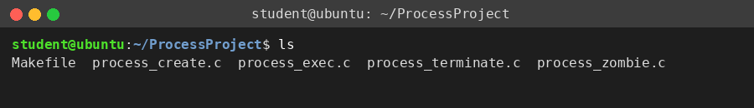
Figure 7.1: Project folder contents before compilation
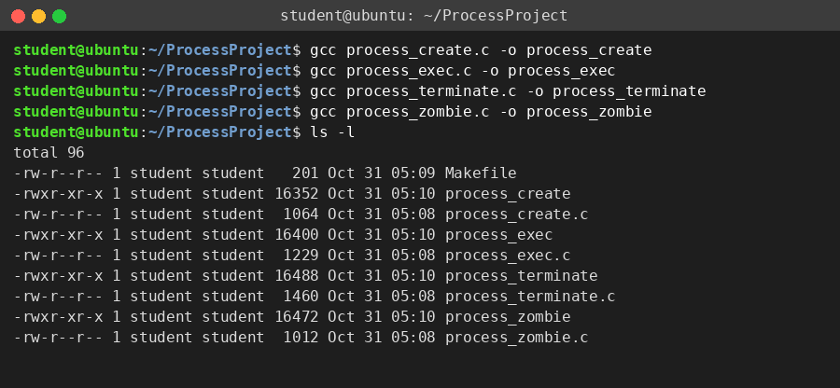
Figure 7.2: Compilation of the four programs and the generated executables
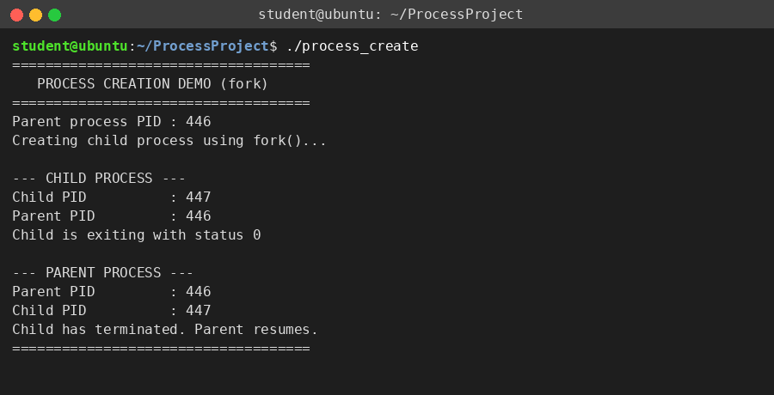
Figure 7.3: Process creation using fork() (TC1)
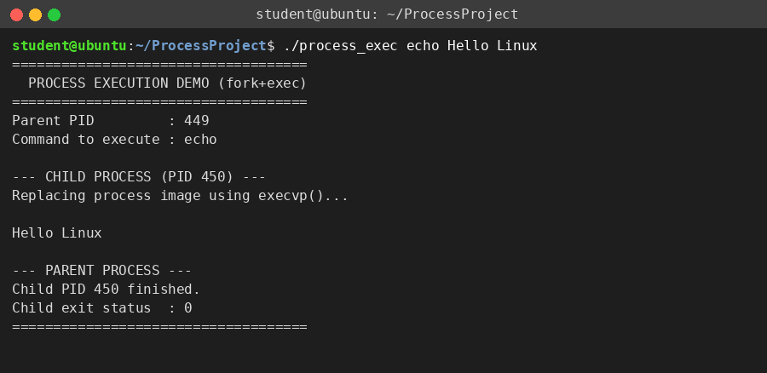
Figure 7.4: Executing echo in the child using execvp() (TC2)
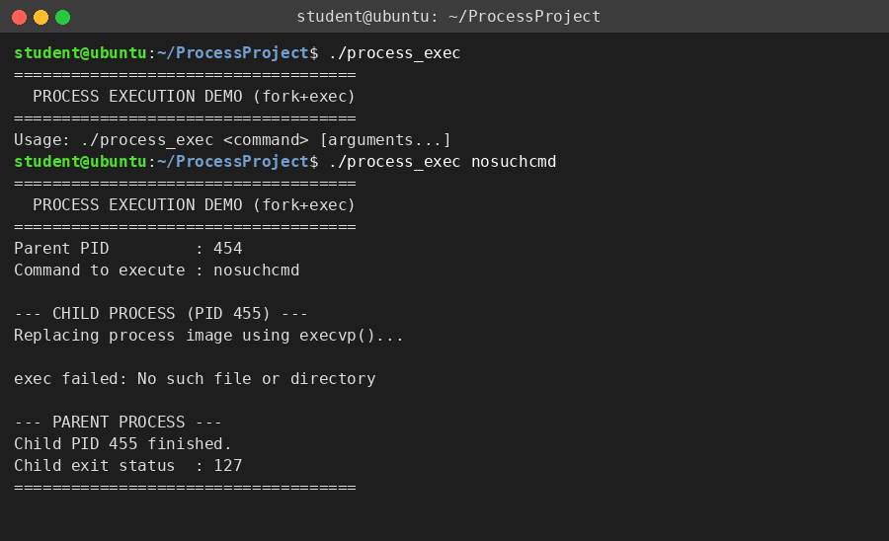
Figure 7.5: process_exec without a command and with a wrong command (TC3 and TC4)
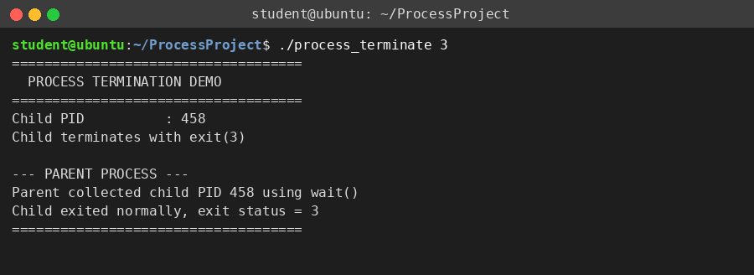
Figure 7.6: Normal termination with exit status 3 (TC5)
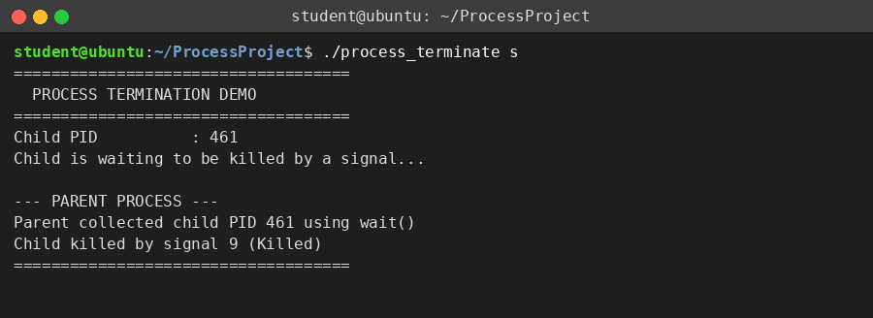
Figure 7.7: Termination by SIGKILL (TC6)
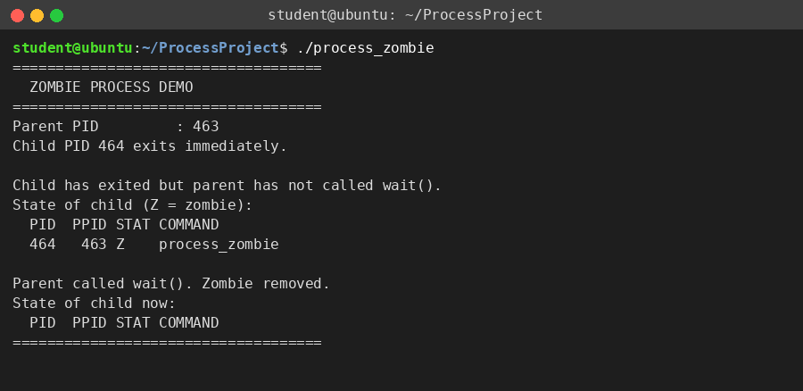
Figure 7.8: Zombie process and its removal (TC7)

7.5 Demonstration of OS Concepts
OS Concept | Where it is seen in the execution
Process creation | fork() creates a child with its own PID (TC1).
Parent-child relationship | The PPID printed by the child equals the PID printed by the parent (TC1).
Return values of fork() | The child receives 0 and the parent receives the child PID, so each branch of the if-else runs in a different process (TC1).
Program execution | execvp() replaces the child with echo, which prints Hello Linux (TC2).
Process synchronization | The parent prints the result only after wait()/waitpid() returns (TC1 to TC7).
Normal termination | The child ends with exit(3) and the parent reads status 3 (TC5).
Abnormal termination | The child is killed by SIGKILL and the parent reads signal 9 (TC6).
Exit status | Status 0 means success, 3 is a user code and 127 means command not found (TC2, TC4, TC5).
Zombie process | ps shows state Z until the parent calls wait() (TC7).
Error handling | A missing command gives a usage message; a failed exec gives a perror() message and status 127 (TC3, TC4).

CHAPTER -8 CONCLUSION

8.1 Summary of the Project

The project "Linux Process Creation, Execution and Termination System" was designed and implemented on Ubuntu using the C language and the GCC compiler. It demonstrates the complete life cycle of a Linux process: creation with fork(), execution of another program with execvp(), termination with exit() or a signal, and collection of the termination status with wait() and waitpid().

Four programs were compiled with GCC and Make and tested with seven test cases covering normal operation, missing input, exec failure, normal termination, termination by a signal and zombie processes. In every test case the printed process identifiers, exit statuses and ps output matched the expected behaviour of the Linux kernel.

8.2 Objectives Achieved

Understood the concept of a process and the parent-child relationship in Linux.

Created child processes using fork() and identified them with getpid() and getppid().

Executed another program in a child process using execvp().

Demonstrated normal termination with exit() and abnormal termination with SIGKILL.

Synchronized the parent with the child using wait() and waitpid().

Read the exit status and signal number using WIFEXITED(), WEXITSTATUS(), WIFSIGNALED() and WTERMSIG().

Demonstrated a zombie process and its removal, and handled error conditions.

8.3 Results Achieved

The child PPID always matched the PID of the parent process.

The child successfully ran a different program using execvp() while keeping its PID.

The parent correctly reported exit status 0, 3 and 127 in the respective test cases.

Termination by a signal was detected correctly and reported as signal 9.

The zombie state (Z) was observed with ps and removed after wait().

All test cases TC1 to TC7 passed, and terminal output and screenshots were documented as evidence.

8.4 Skills and Learning Outcomes

C programming with processes, pointers and command-line arguments.

Linux system programming using fork(), execvp(), wait(), waitpid(), exit() and signals.

Understanding of process creation, program execution, process states, exit status and zombie and orphan processes.

Compiling and running programs in the Ubuntu terminal with GCC and Make.

Testing a program with different inputs and documenting the results.

Using Git and GitHub to manage the project files, and teamwork in sharing the implementation between three members.

CHAPTER -9 REFERENCES

9.1 Books

[1] A. Silberschatz, P. B. Galvin and G. Gagne, Operating System Concepts, 10th ed., Wiley, 2018.

[2] B. W. Kernighan and D. M. Ritchie, The C Programming Language, 2nd ed., Prentice Hall, 1988.

[3] W. R. Stevens and S. A. Rago, Advanced Programming in the UNIX Environment, 3rd ed., Addison-Wesley, 2013.

[4] M. Kerrisk, The Linux Programming Interface, No Starch Press, 2010.

[5] A. S. Tanenbaum and H. Bos, Modern Operating Systems, 4th ed., Pearson, 2014.

9.2 Research Papers

[6] D. M. Ritchie and K. Thompson, "The UNIX Time-Sharing System," Communications of the ACM, vol. 17, no. 7, pp. 365-375, 1974.

[7] A. Baumann, J. Appavoo, O. Krieger and T. Roscoe, "A fork() in the road," Proceedings of the Workshop on Hot Topics in Operating Systems (HotOS), 2019.

9.3 Linux / GNU Documentation

[8] Linux manual pages: fork(2), execve(2), exec(3), wait(2), exit(3), signal(7), kill(2), ps(1). https://man7.org/linux/man-pages/

[9] GNU Compiler Collection (GCC) Online Documentation. https://gcc.gnu.org/onlinedocs/

[10] The GNU C Library Reference Manual - Processes. https://www.gnu.org/software/libc/manual/

[11] The Open Group, POSIX.1-2017 (IEEE Std 1003.1-2017) Base Specifications. https://pubs.opengroup.org/onlinepubs/9699919799/

9.4 Online Resources

[12] GNU Make Manual. https://www.gnu.org/software/make/manual/

[13] Ubuntu Documentation. https://ubuntu.com/tutorials

[14] Microsoft Learn: Windows Subsystem for Linux Documentation. https://learn.microsoft.com/en-us/windows/wsl/

